GENERAL INSTALLATION INSTRUCTIONS
VST Synths presets load instruction
Spire
Click Menu > Load Bank > Choose Downloaded Bank File

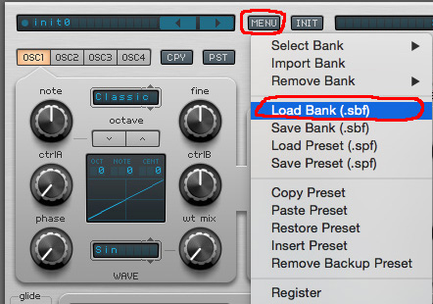
Sylenth
Click Menu > Load Bank > Choose Downloaded Bank File
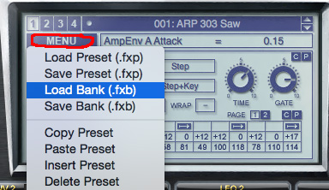

Massive
Click Brows > Click Sounds > Choose Downloaded folder with patches > Change patches at right section
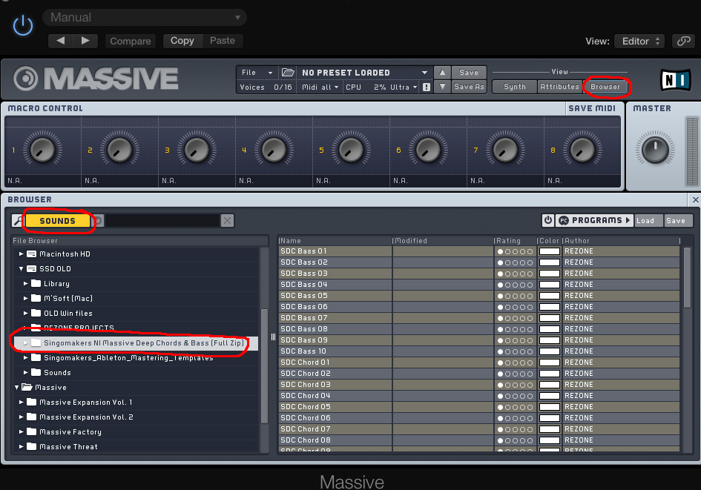

SERUM
Find on your Mac/PC “Serum Presets” folder, and copy download folder with our patches into “Serum Presets”, after it you will be able to choose patches in serum plugin. 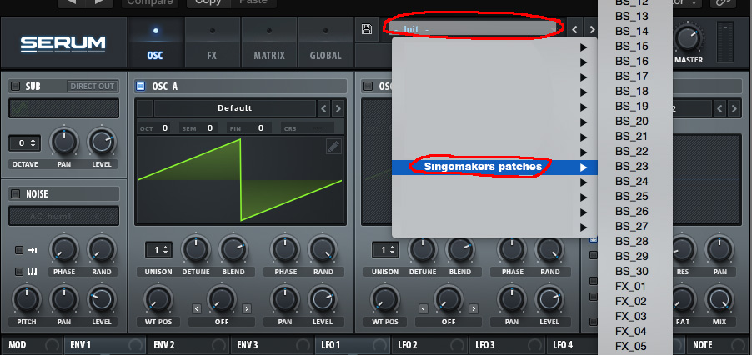

These are General install instructions and some products may vary with contents

REASON 4 REFILL

Copy the Singomakers .rfl file, to the Reason installation folder on your hard drive.
Use Reason’s Browser to load instruments or effects from the Loopmasters refill.

ABLETON LIVE 7+ PACK

Copy the .alp file to your desktop.
Double click the file and live will boot up and ask where you would like to install the project folder.

If you wish to use any instrument presets that are contained in the sample pack in other projects, then use Live’s Browser to locate the project folder, right click over it and select MANAGE PROJECT.
Then on the right hand side of the screen select EXPORT. The presets and sounds should now be located in your Ableton Library.

Many Thanks For Your Purchase and Enjoy Your Samples!

Sincerely Yours,
Singomakers

info@djrezone.com
http://www.facebook.com/Singomakers
www.loopmasters.com/singomakers
http://www.youtube.com/singomakers

Free samples from Singomakers:
https://www.facebook.com/Singomakers/app_1377770235884432?ref=page_internal

